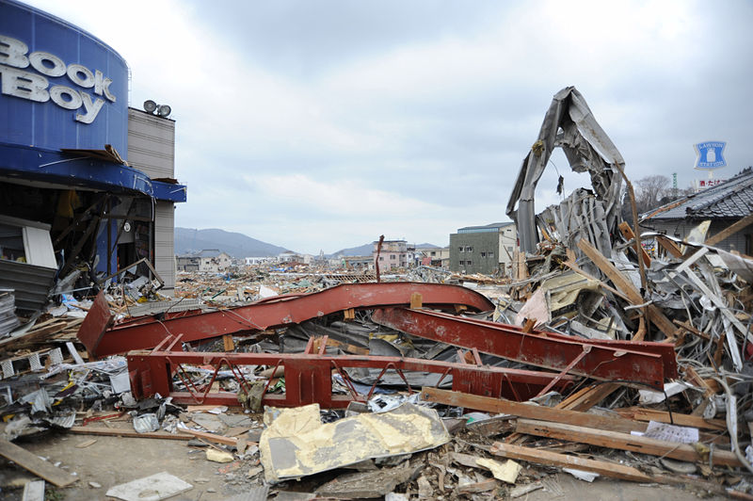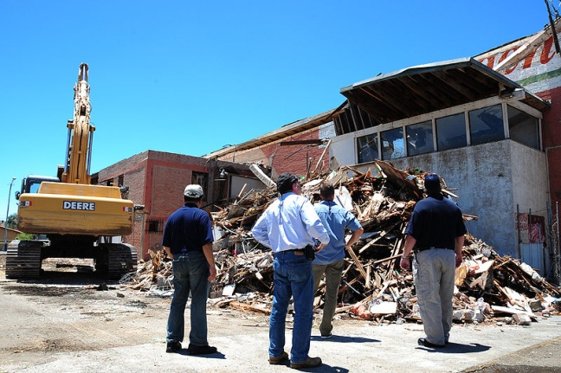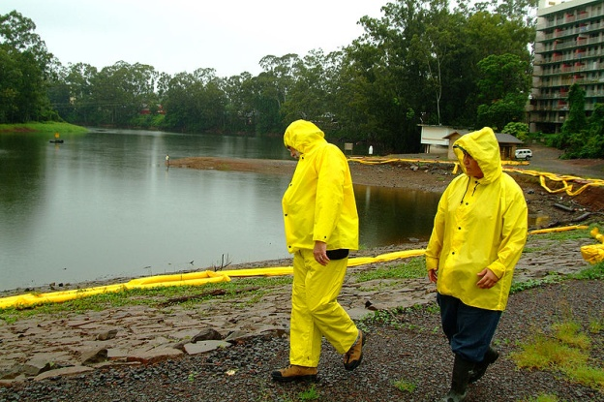

**Business Continuity Plan Test**

**Facilitator & Evaluator Handbook**

This page is intentionally left blank.

# Preface

The Business Continuity Plan Test was developed as a mechanism for testing Business Continuity Plans.

This Facilitator and Evaluator Handbook is an unclassified exercise document and is intended FOR EXERCISE USE ONLY. Due to the nature of the information discussed, special considerations may be applicable for document access and storage. All exercise participants should use the appropriate guidelines to protect this material in accordance with their jurisdictional directives.

This page is intentionally left blank.

# Handling Instructions

1. The title of this document is the *Business Continuity Plan Test Facilitator & Evaluator Handbook.*
2. Information derived from the *Facilitator & Evaluator Handbook* should be handled according to the facility/organization guidelines based on sensitivity of information.
3. At a minimum, the attached materials should only be disseminated on a need-to-know basis to applicable partners.

This page is intentionally left blank.

# Table of Contents

Preface i

Handling Instructions iii

Table of Contents v

Recommended Agenda vii

Introduction 1

Appendix A: Exercise Write-Up Template A-1

Appendix B: Target Capabilities B-1

Appendix C: Acronym List C-1

This page is intentionally left blank.

# Recommended Agenda

Registration: 8:30 a.m. – 9:00

Introduction: 9:00 – 9:15

Scenario Module 1: 9:15 – 10:00

Scenario Module 2: 10:00 – 10:45

Break: 10:45 – 11:00

Scenario Module 3: 11:00 – 11:45

Hot Wash: 11:45 – 12:30 p.m.

End: 12:30 p.m.

**Note:** This agenda assumes that a facility is exercising three of the four possible scenarios. An organization is free to exercise as many of the scenarios as it chooses. The agenda should be adjusted accordingly if an organization elects to exercise more than three scenarios.

Facilitators and evaluators will meet for about one hour after the exercise for a debriefing.

This page is intentionally left blank.

# Introduction

**Purpose**

The purpose of the Business Continuity Plan (BCP) Test is to create an opportunity for businesses to identify and examine the issues and capability gaps they are likely to face in implementing their BCPs and in recovering from business operation disruptions.

**Scope**

The BCP Test focuses on a facility’s recovery efforts following selected business disruptions intended to represent a broad spectrum of disruption threats: hurricane, earthquake, ice storm, and blackout. The intent is to improve the overall recovery capabilities and actions and the collective decisionmaking process. It is designed to be an open, thought-provoking exchange of ideas to help develop and expand existing knowledge of policies and procedures within the framework of BCP implementation.

**Target Capabilities**

The National Planning Scenarios and the establishment of the National Preparedness Priorities have steered the focus of homeland security toward a capabilities-based planning approach. Capabilities-based planning focuses on planning under uncertainty, since the next danger or disaster can never be forecast with complete accuracy. Therefore, capability-based planning takes an all-hazards approach to planning and preparation, thus building capabilities that can be applied to a wide variety of incidents. The capabilities below provided the foundation for developing the exercise objectives and scenario:

* Planning (see Appendix B for more information related to this capability);
* Economic and Community Recovery (see Appendix B for more information related to this capability).

For additional reading and insight into the Target Capabilities List (TCL) and evaluation process, please refer to the links below. The purpose of this exercise is to measure and validate performance of these capabilities and their associated critical tasks. Not all the capabilities may be applicable to your facility.

TCL: <http://www.fema.gov/pdf/government/training/tcl.pdf>

TCL User Guide: <http://www.iaem.com/committees/GovernmentAffairs/documents/TargetCapabilitiesUserGuide_17February2009.pdf>

**Recommended Objectives**

Listed below are recommended objectives for the BCP Test. It is the decision of the exercise planner/facilitator to cover some or all of the four objectives and/or draft new objectives. Ensure the “Exercise Objectives” slide of the BCP Test PowerPoint presentation and page 1 of the Situation Manual correctly identify the objectives selected.

1. Discuss and validate internal BCP implementation procedures in response to various incidents in accordance with existing plans and procedures.
2. Discuss and validate the effectiveness of BCP functions in directing and controlling recovery activities in accordance with existing plans and procedures.
3. Assess the ability to identify critical functions, actions, and timeframes to facilitate short- and long-term recovery.
4. Identify gaps, redundancies, developmental activities, and best practices in the event of a catastrophic incident.
5. Add personalized exercise objectives as necessary.

**Exercise Participants**

* *Players* respond to the situation presented based on knowledge of current plans, procedures, and insights derived from training and experience.
* *Observers* observe the exercise; they are not participants in the moderated discussion.
* *Facilitators* provide situation updates and moderate discussion. They also provide additional information or resolve questions as required.
* *Evaluators* are responsible for gathering relevant data arising from facilitated discussions during the exercise. They will then use this information to collectively build an After Action Report and Improvement Plan (AAR/IP).

**Exercise Structure**

The BCP Test is a moderated discussion-based exercise that allows participants to interact in accordance with their respective responsibilities and expertise to coordinate the response to and recovery from a significant incident.

The entire BCP Test is a recommended three- to four-hour, scenario-driven, facilitated exercise. Players will utilize between one and four exercise scenario modules. The number of modules utilized will be decided by the exercise planner(s). A series of general questions following the scenario summary will guide the facilitated discussion of critical issues in each of the modules. **The questions are not meant to constitute a definitive list of items or concerns to be addressed, nor is there a requirement to discuss every question.** Participants may identify additional critical questions, issues, and decisions as they pertain to the specific module. Based on exercise priorities, time dedicated to each module will be managed by the facilitator.

**Exercise Guidelines**

* This is an open, low-stress, no-fault environment. Varying viewpoints, even disagreements, are expected.
* Comments will be non-attribution, using the “Chatham House” rule.
* Responses should be based on knowledge of current plans and capabilities (i.e., use only existing capabilities) and insights derived from training.
* Decisions are not precedent-setting and may not reflect your organization’s final position on a given issue. This is an opportunity to discuss and present multiple options and possible solutions.
* Problem-solving efforts should be the focus. Issue identification is not as valuable as suggestions and recommended actions.
* The situation updates, written material, and resources provided are the basis for discussion; there are no situational, or surprise injects.

**Assumptions and Artificialities**

In any exercise, a number of assumptions and artificialities may be necessary to complete play in the time allotted. During this exercise, the following apply:

* The scenarios are plausible and events occur as they are presented;
* There are neither “hidden agendas,” nor any “trick questions;”
* All players receive information at the same time;

The scenarios are completely artificial; and

Assume cooperation and support from other responders and agencies as appropriate.

**Observing and Evaluating the Exercise**

Facilitators and evaluators must keep an accurate written record of what occurs. To be reliable, they should take notes as players discuss actions, make decisions, and present their capabilities. Notes should identify the following:

* *Who* made the decision (by name or position);
* *What* occurred (the observed decision);
* *Why* the decision was made (the trigger);
* *How* the decision was made (the process); and
* *What* was the outcome of decisions? Was a solution identified? Who is responsible for the identified solution? In what time frame will the solution be completed/implemented?

Effective notes will assist when writing the final analysis. During the exercise, it is important to concentrate on recording what is happening, specifically what is discussed by the group as it relates to the exercise objectives and capabilities identified. Lengthy and detailed writing during the exercise can cause evaluators to miss important discussions among participants.

Knowing which events are important makes recording the action manageable, eliminates superfluous information, and provides the kind of data most useful for the after-action process.

Items and issues to be aware of during the discussion include:

* Existing plans or procedures which will help the organization achieve the stated exercise objective(s) and demonstrate the appropriate capability;
* Deviations from those plans and implementation procedures;
* Roles and responsibilities of players with actions and decisions related to the exercise objectives and capabilities (if applicable);
* Decisions made by exercise players;
* Recommendations offered by players; and
* Any unresolved issues discussed during the exercise.

**Hot Wash**

Immediately after the exercise, a “hot wash” will be conducted with the players, facilitators, and evaluators. A hot wash affords players the ability for self-assessment and discussion on the outcomes of the exercise. During the hot wash, the lead facilitator gives every participant the opportunity to provide feedback on what went well during the exercise as well as areas for improvement.

The hot wash also provides the evaluators with the opportunity to clarify points or collect any missing information from the players before they leave the area. To supplement the information collected during the player hot wash, the evaluation team distributes participant feedback forms to obtain anonymous responses from participants on their perception of the exercise.

**Facilitator and Evaluator Debriefing**

Following the hot wash, facilitators and evaluators should conduct their own debriefing to reconcile conflicting outcomes and solidify common themes. At the debriefing, facilitators and evaluators will further discuss the performance of the exercise participants. In addition, facilitators and evaluators will provide what they thought were three strengths and three areas for improvement observed during the exercise. This is often referred to as “three ups” and “three downs.” These strengths and areas for improvement are based on the general impression of the facilitators and evaluators immediately after the exercise and should be relevant to the selected capabilities.

**Analyze Data**

The goal of data analysis is to assess performance by identifying what aspects of the exercise went well and what areas need improvement. The analysis compares players’ discussions with existing plans and procedures. Steps to take to analyze the data include:

1. Reviewing exercise discussion notes;
2. Comparing player discussions to existing plans, identifying deviations and determining why they occurred; and
3. Listing recommendations to resolve issues.

During data analysis, the evaluator consolidates the data collected during the exercise and transforms it into narratives that address the course of exercise play, demonstrated strengths, and areas for improvement.

A template for an exercise write-up (and analysis of the identified issues) is provided in Appendix A of this handbook.

**Identify Root Causes and Develop Recommendations**

To produce an AAR/IP with recommendations for improving preparedness capabilities it is critical for evaluators to discover not only what happened, but why those actions were chosen. Evaluators must find the root cause for insufficient actions. A root cause is the source of, or underlying reason behind, an identified issue (as uncovered during analysis) toward which the evaluator can direct an improvement. To arrive at a root cause, an evaluator should attempt to trace each item back to its origin. Root cause analysis may require the review and evaluation of emergency plans, training programs, policies, and procedures.

Uncovering root causes enables the development of actionable solutions for improvement areas identified in the AAR/IP. These recommendations are based on the evaluation team’s experience and best judgment, although the responsibility for implementing recommendations ultimately lies with the leaders and managers of the participating agencies or organizations.

Evaluators should use the following questions as a guide for developing recommendations for improvement:

* Were the objectives of the exercise met?
* Did the discussion suggest that all personnel would be able to successfully complete the tasks necessary to execute the activity? If not, why?
* What are the key decisions associated with each activity?
* Did the discussion suggest that all personnel are adequately trained regarding the activities/tasks discussed to achieve the capability?
* Did the discussion identify any resource shortcomings that could inhibit the ability to execute an activity?
* Do the current plans, policies, and procedures support the performance of activities? Are players familiar with these documents?
* Do personnel from multiple agencies or jurisdictions need to work together to perform a task, activity, or capability? If so, are there agreements or relationships in place to support the coordination required?
* What was learned from this exercise?
* What strengths were identified for each activity?
* What areas for improvement are recommended for each activity, if any?

**After Action Report and Improvement Plan**

An AAR/IP is used to provide feedback to participating entities on their performance during the exercise. The AAR/IP summarizes exercise events and analyzes performance of the tasks identified as important during the planning process. It also evaluates achievement of the selected exercise objectives of the overall capabilities being validated. The Improvement Plan portion of the AAR/IP includes corrective actions for improvement, along with timelines for their implementation and assignment to responsible parties.

It is important for evaluators to exchange contact information with the facilitator. An abundance of data is captured by each evaluator and this information is consolidated to produce the AAR/IP.

If the execution of the exercise involves multiple tables, then each table’s evaluator should coordinate with the facilitator to ensure all relevant information is consolidated into a table report. Next, each table’s report should be consolidated and submitted to a single individual for the AAR/IP.

The facilitator must determine when exercise write-ups are due and ensure the evaluators are given a **no later than date** for submission. It is recommended the After Action Report portion of the AAR/IP is completed by a single individual utilizing the HSEEP process.

The table evaluator and the AAR representative can utilize the sample Exercise Write-up Template located in Appendix A.

# Appendix A: Exercise Write-Up Template

**Capability 1: [Capability Name]**

**Capability Summary:** [Include a detailed overview of the capability, drawn from the TCL descriptions, and a description of how the capability was performed during an operations-based exercise or addressed during a discussion-based exercise. The exact length of this summary will depend on the scope of the exercise.]

**Activity 1:** [Using the Target Capabilities provided in the appendices, identify the activity to which the observation(s) below pertain.]

**Observation 1.1:** [Begin this section with a heading indicating whether the observation is a “Strength” or an “Area for Improvement.” A strength is an observed action, behavior, procedure, or practice that is worthy of recognition and special notice. An area for improvement is an area in which the evaluator observed that a necessary task was not performed, or that a task was performed with notable problems. Following this heading, insert a short sentence that describes the general observation.]

**References:** [List relevant plans, policies, procedures, laws, and regulations, or sections that apply. If no references apply to the observation, it is acceptable to simply list “N/A” or “Not Applicable.”]

1. [Name of the task and the applicable plans, policies, procedures, laws, and regulations and 1 – 2 sentences describing their relation to the task]
2. [Name of the task and the applicable plans, policies, procedures, laws, and regulations and 1 – 2 sentences describing their relation to the task]

**Analysis:** [The analysis section should be the most detailed section. Include a description of the behavior or actions at the core of the observation, as well as a brief description of what happened and the consequence(s) (positive or negative) of the action or behavior. If an action was performed successfully, include any relevant innovative approaches used by the exercise participants. If an action was not performed adequately, the root causes contributing to the shortcoming must be identified.]

**Recommendations:** [Insert recommendations to address identified areas for improvement based on the judgment and experience of the evaluation team. If the observation was identified as a strength, without corresponding recommendations, insert “None.”]

1. [Complete description of recommendation]
2. [Complete description of recommendation]
3. [Complete description of recommendation]

**[Continue to add additional observations, references, analyses, and recommendations for each capability as necessary. Maintain numbering convention to allow for easy reference.]**

**Sample Write-Up**

**Capability 1: Intelligence and Information Sharing and Dissemination**

**Capability Summary:** The Intelligence and Information Sharing and Dissemination capability provides necessary tools to enable efficient prevention, protection, response, and recovery activities. The goal is to get the right information to the right people at the right time. The University of California, Davis (UCD), utilized a variety of methods for information distribution on their campus to advertise the Flu Clinic to their population.

**Activity 1.1:** Develop and Maintain Plans, Procedures, Programs, and Systems

**Observation 1.1:** Strength—Standard activation procedures for the Yolo County Strategic National Stockpile (SNS) Plan include alerting each site being used that activation is imminent as soon as possible, so that they have enough time to assign personnel, set up, and gather supplies. The Health Department followed all standard activation procedures for this drill including California Health Alert Network (CAHAN) and fax communications beginning December 1, 2008.

**References:**

1. Yolo County Strategic National Stockpile Plan

**Analysis:** This was helpful for requesting information on procedures that could change from day to day (example: a CAHAN and fax were sent to UCD Emergency Operations Center (EOC) staff asking them to provide the procedure for driving access to Freeborn Hall on the day of the drill). Parking permits were then procured by the university and stored (in the front kiosk at the North-Quad entry gate) for county delivery personnel to utilize on the day of the drill. Since the university may have their own staging site on campus for supplies, the delivery gate could change depending on the incident and site(s) being used. This method of requesting information would be very important during an actual activation.

**Activity 1.2:** Develop and Maintain Training and Exercise Programs

**Observation 1.2:** Area for Improvement—While the activation protocols for this exercise functioned properly in this instance, it is recommended that these procedures be tested with all Push Partner entities, at least annually, so that they are familiar with the procedure.

**Analysis:** This drill was carefully planned by both UCD and the Yolo County Health Department, which enabled all those participating to be knowledgeable about the activation procedures. This method now needs to be tested with other participating jurisdictions so that all are fully aware of the procedure.

**Recommendations:**

1. Enroll more site facility administrators into the Health Alert Network and test it regularly.

**Activity 1.3:** Vertically Flow Information

**Observation 1.3:** Strength—This was the first Yolo County Health Department drill where the advertising and messaging about the clinic was completed by an outside entity (UCD). The university redistributed information from the Centers for Disease Control (CDC) Web site and local Health Department Public Information Officer in the form of press releases and advertising for the clinic.

**References:**

1. Centers for Disease Control Seasonal Influenza Web site http://[www.cdc.gov/flu](http://www.cdc.gov/flu)
2. UCD Developed Web site <http://www.ucdavis.edu/help/safety.html>

**Analysis:** Since the university has control over all methods of information distribution on their campus, it was very helpful that they were the entity pushing the message out. The methods of dissemination that they used for this included; writing on chalk boards in class rooms, creating and publicizing MySpace and Facebook events, placing ads in the student newspaper, setting up tables with ads prior to the event, posting articles in staff and student newspapers, creating a Web site, posting flyers on campus bulletin boards, posting events on Memorial Union electronic “event boards,” emailing flyers through student clubs (ASUCD, Honors Challenge, sororities/fraternities), distributing flyers through student housing and various other departments, canvassing campus the day before and day of the event to recruit participation, and posting signage at key junctions the day before and day of the event. It is also noteworthy to mention that most of the above-listed actions began on December 1, 2008 (two days before the actual clinic).

**Recommendations:**

1. For future exercises, try to get partner agencies to take an active role in information dissemination.

# Appendix B: Target Capabilities

The following excerpts are taken from the Department of Homeland Security’s September 2007 TCL.

**Economic and Community Recovery**

Economic and Community Recovery is the capability to implement short- and long-term recovery and mitigation processes after an incident. This will include identifying the extent of damage caused by an incident, conducting thorough post-event assessments and determining and providing the support needed for recovery and restoration activities to minimize future loss from a similar event.

**Planning**

Planning is the mechanism through which Federal, State, local and tribal governments, non-governmental

organizations (NGOs), and the private sector develop, validate, and maintain plans, policies, and procedures describing how they will prioritize, coordinate, manage, and support personnel, information, equipment, and resources to prevent, protect and mitigate against, respond to, and recover from Catastrophic events.

# Appendix C: Acronym List

| **Acronym** | **Definition** |
| --- | --- |
| **AAR/IP** | After Action Report/Improvement Plan |
| **DHS** | U.S. Department of Homeland Security |
| **FEMA** | Federal Emergency Management Agency |
| **HSEEP** | Homeland Security Exercise and Evaluation Program |
| **IP** | Office of Infrastructure Protection |
| **NPPD** | National Protection and Programs Directorate |
| **TCL** | Target Capabilities List |
| **UTL** | Universal Task List |

This page intentionally left blank.