#WinterReady Partners Toolkit

Purpose
This toolkit provides messaging, graphics and resources to help you community protect lives, educate the public on the risks of winter weather, promote fire safety, and urge caution when travelling in winter weather.
By using the hashtag #WinterReady and sharing winter safety and preparedness messages you can provide information to your communities and encourage survivors to:
- Know their winter weather risk.
- Be fire safe.
- Travel with supplies and caution.
- Take steps now to prepare.
    - About the Campaign
Launched in mid-November, the #WinterReady campaign acknowledges that while individuals and communities across the nation face severe winter weather with different levels of experience and infrastructure to handle extreme winter events. Because winter weather brings risks that can be avoided with appropriate preparation, this campaign will run through the end of February.
    - Toolkit Sections
Websites
Sample Text for E-mails, Handouts, Flyers and More
Sharable Graphics and Suggested Content
#WinterReady Printable Flyers
#WinterReady Social Media Toolkits
General Preparedness Videos/PSAs
FEMA Podcasts, Blogs and Webinars
    - Websites
- #WinterReady | Ready.gov
The #WinterReady page has tips and resources people can use to learn how to protect themselves from common cold-weather risks, including frostbite and hypothermia, home heating fires, carbon monoxide poisoning and preparing for winter travel. The page also includes steps people can take to prepare for power outages and tips for people who need low-cost solutions for home heating are an older adult, work or play outside, or don’t typically experience winter weather,
- Listo.gov: Razones para estar #WinterReady
The Listo page has the same resources as the English language #WinterReady page.
- USFA | Prevent Home Fires
The U.S. Fire Administration has many downloadable, co-brandable graphics and materials on a wide variety of fire safety topics for social media and beyond.
- CDC | Educational Materials by Topic | Disasters
- CDC | Hypothermia | Winter Weather
The Centers for Disease Control and Prevention educational materials page has fact sheets, flyers and pictograms in multiple languages for many common cold-weather hazards, including carbon monoxide poisoning, generator and furnace safety. Additionally, materials on preventing, recognizing and treating hypothermia are available in English and Spanish at the second link above.
    - Sample Text for E-mails, Handouts, Flyers and More
While heat waves are on the increase and garner well-deserved attention from the media, a recent study by the Centers for Disease Control and Prevention (CDC) found that far more deaths occur due to exposure to the cold. In fact, an analysis by the CDC of U.S. temperature-related deaths between 2006 and 2010 showed that 63% were attributable to cold exposure. Cold weather brings other risks, like home fires and travel risks – especially if you travel by car. That’s want everyone to be #WinterReady so they can stay safe during the winter months.
Understanding the hazards and risks associated with cold weather and winter storms is the first step to make sure you’re #WinterReady. Like preparing for other natural hazards, you should have emergency supplies at home, at work and in the car. You should also understand how to prevent home heating fires and carbon monoxide poisoning. Visit #WinterReady | Ready.gov to learn about some of the common hazards you might face when the weather turns cold. Because some people have situations that need a little more attention, the page includes low-cost solutions for home heating, advice for older adults, and those work or play outside or don’t typically experience winter weather. The page also has downloadable resources on staying warm, winterproofing your home, winter travel safety and preparedness flyers from our federal partners.
    - Sharable Social Media Graphics and Recommended Text
Additional #WinterReady Safety Graphics will be available throughout the campaign, so be sure the check back frequently.
        - Sample Generic #WinterReady Social Media Messages:
- Stay #WinterReady and know the signs of frostbite & hypothermia ahead of time:
-Frostbite: Numb, gray-yellow or waxy skin.
-Hypothermia: Shivering, exhaustion, confusion.
- Bundling up and staying dry are two of the best things you can do to stay safe from cold temperatures this fall and winter. Learn to protect yourself from the cold at: ready.gov/winter-ready
- If a snowstorm is heading to your area, have different ways to receive information:
- Sign up for alerts from your local U.S. National Weather Service (NWS) office.
- Download the FEMA mobile app to get safety tips.
- Check the Wireless Emergency Alert settings on your phone: ready.gov/alerts.
  - Get #WinterReady: make a plan to connect before a storm by text, e-mail, social media & cell: www.ready.gov/plan #WinterReady
  - Learn how to stay safe before, during, & after winter storms & extreme cold by visiting: ready.gov/winter-ready #WinterReady
  - Talk with your family about how to get prepared for extreme #cold weather: www.ready.gov/kids/know-the-facts/winter-storms-extreme-cold #WinterReady
  - Before a winter storm, know what to do “When the Sky Turns Gray.” Watch this: www.youtube.com/watch?v=XVpGJ_Xl__w #WinterReady
  - Follow weather alerts in up to 5 locations using the @fema app. Learn more: https://youtu.be/DtF18YHjG-I #WinterReady
  - Stay safe during winter weather. Monitor weather alerts and have a preparedness kit ready. www.ready.gov/kit #WinterReady
  - Prepare for winter storms and cold weather with the kids by playing the disaster master game: www.ready.gov/kids/games. Password hint: SLEET
  - Snow Prep tips: check on neighbors, charge cell phones, find flashlights (check batteries) and follow local officials online. #WinterReady
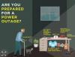 Prepare for Power Outage Download Graphic

Be a Good Neighbor! Download Graphic
Un-Prepared Download Graphic

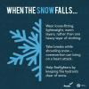 When the Snow Falls Download Graphic

        - Home Heating Safety Social Media Messages and Graphics:
          - Space Heaters:
- Space heaters cause 1/3 of home heating fires and 4/5 home heating fires deaths. Protect your family with tips from USFA http://www.nfpa.org/public-education/by-topic/top-causes-of-fire/heating #WinterReady
- Staying warm with a space heater? Make sure it has an auto shut-off in case it tips over. Check on family/friends today #WinterReady
- Keep anything that can burn at least 3 feet away from a fireplace, wood stove, or space heater. #WinterReady
- Watch this short video from @usfa to learn how to prevent portable heater fires in your home this winter: http://www.youtube.com/watch?v=9AMQ1ASnmNU

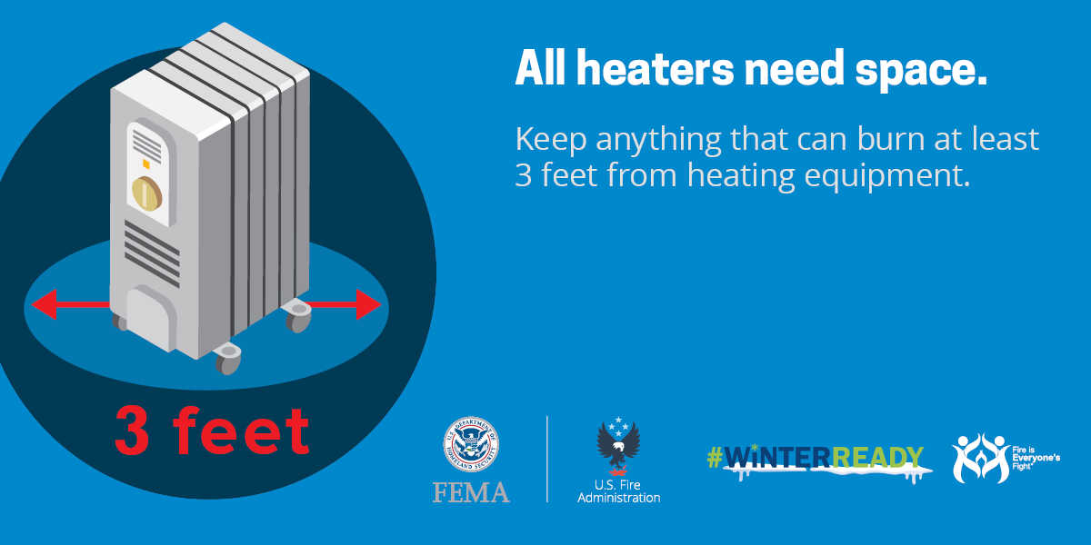 All Heaters Need Space English
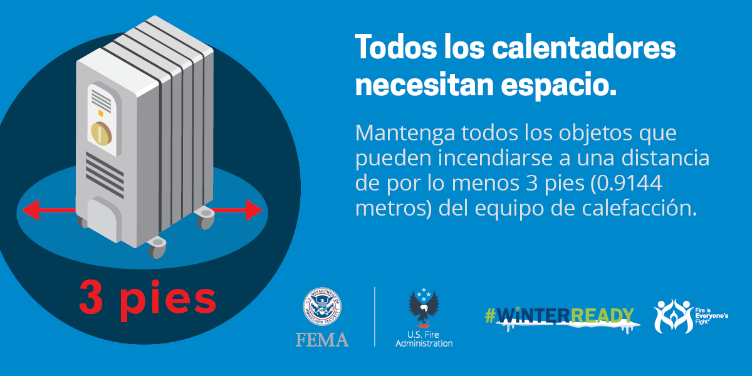 All Heaters Need Space Spanish
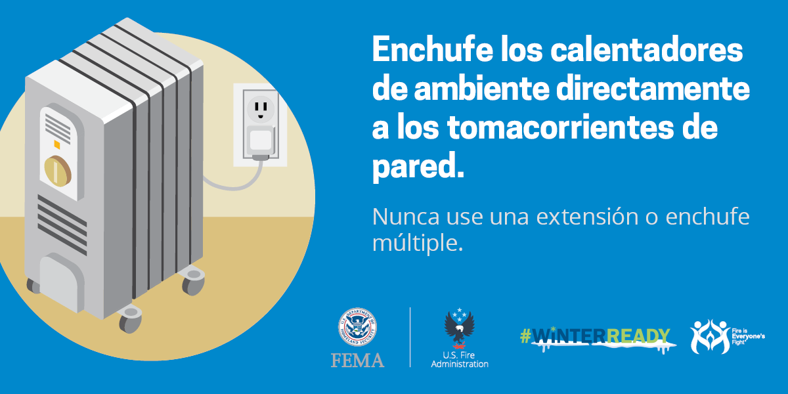Plug Space Heaters into Wall Outlets English
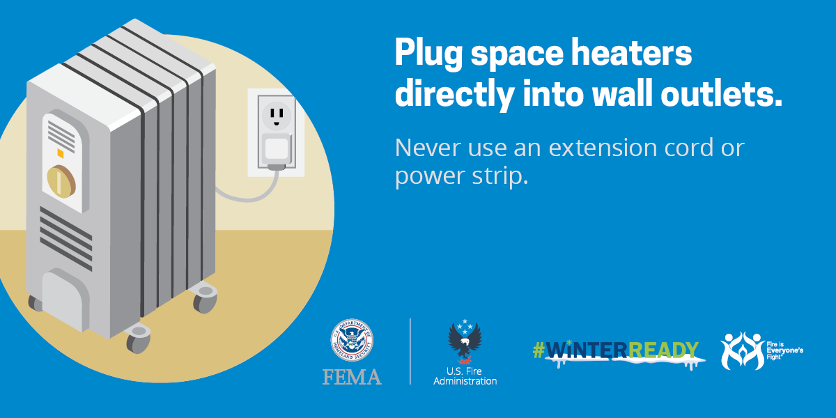Plug Space Heaters into Wall Outlets Spanish
          - Heating General Safety:
- Heating is the 2nd leading cause of home fires after cooking. Get #WinterReady tips from USFA www.usfa.fema.gov/prevention/outreach/heating.html
- Winter fires can be deadly. When using your fireplace always keep a metal or heat tempered screen around it to stay safe. #WinterReady
- If you’re running a portable generator, you need to have a working carbon monoxide alarm in your home. #WinterReady
- #WinterReady Tip: NEVER use a generator, camp stove, charcoal grill, gasoline or propane heater indoors.
- NEVER heat a home by using the stovetop or oven. #WinterReady
- #DYK? Home heating is the second leading cause of home fires, and winter is when most home fires happen. Download the free Home Fire Safety Guide from @USfire and learn about how to prepare for and prevent home fires at http://ready.gov/winter-ready. #WinterReady
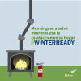 Stay Safe When Heating Your Home (Spanish)(Square) Download Graphic

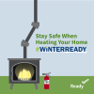 Stay Safe When Heating Your Home (Square) Download Graphic
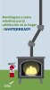 Stay Safe When Heating Your Home (Spanish)(Instagram Story) Download Graphic
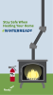 Stay Safe When Heating Your Home (Instagram Story) Download Graphic
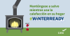 Stay Safe When Heating Your Home (Spanish)(Facebook and Twitter)Download Graphic
    - 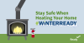 Stay Safe When Heating Your Home (Facebook and Twitter) Download Graphic

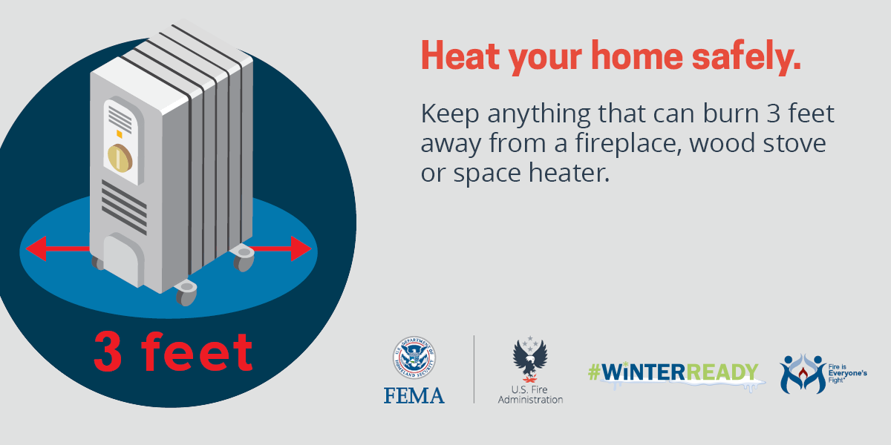 Heat Your Home Safely English
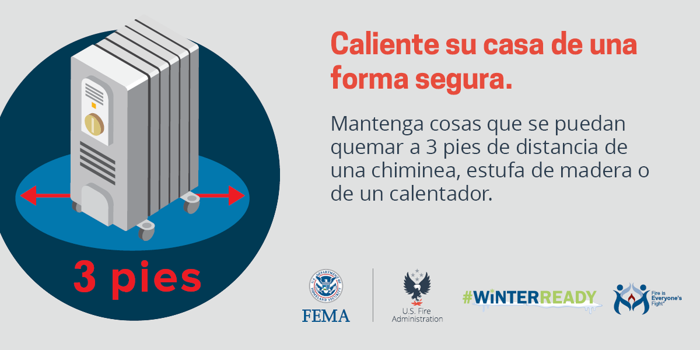 Heat Your Home Safely Spanish
Never Use Your Oven Or Stove For Heat gif in English
Never Use Your Oven Or Stove For Heat gif Spanish.
          - Clean Your Chimney:
- Winter is here! Are you using a chimney or fireplace to stay warm?
Remember:
- Keep anything that can burn at least 3 feet from all heat sources
- Do not burn paper or other materials
- Put the fire out before you go to bed or leave the house
For more tips, follow U.S. Fire Administration
- Have chimneys, vents and woodstove pipes cleaned and inspected by a qualified professional at least once a year. For more tips, follow U.S. Fire Administration

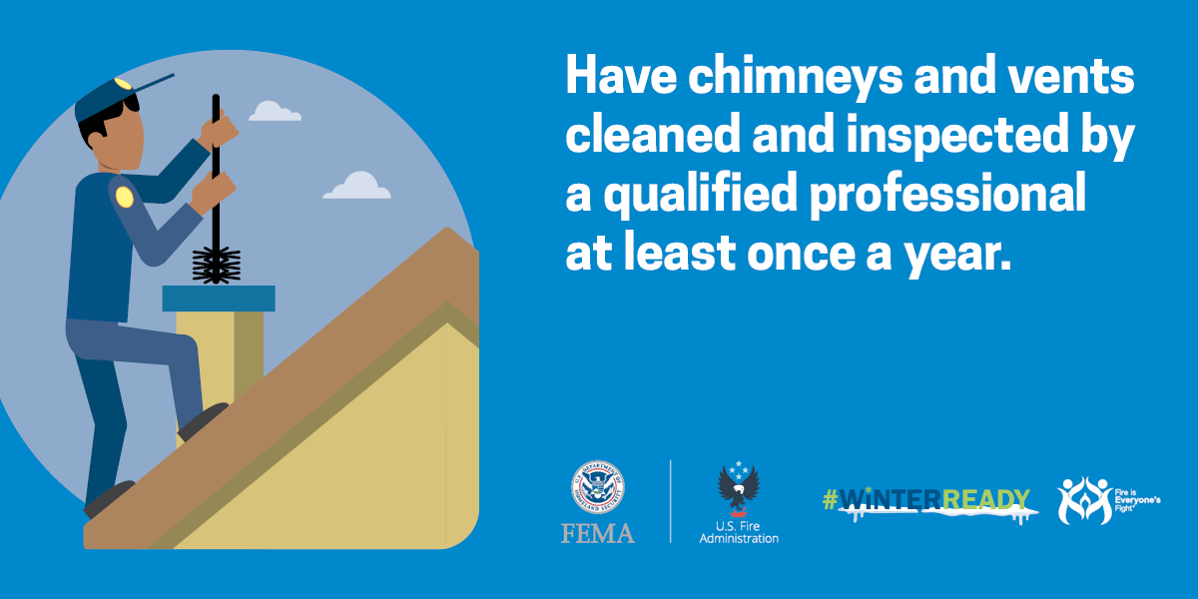 Have Chimneys And Vents Inspected gif English
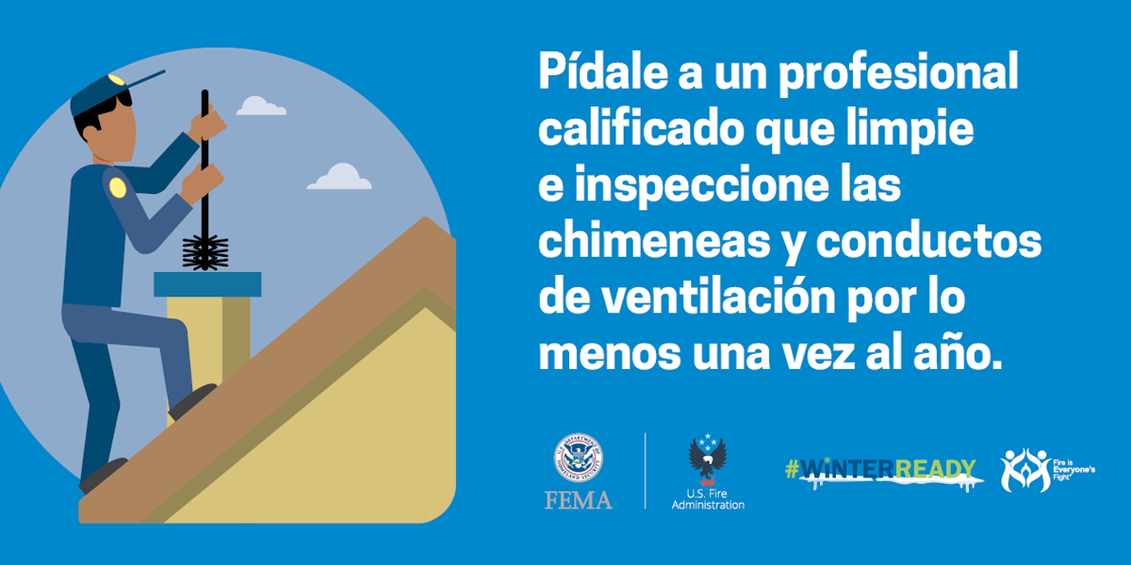 Have Chimneys And Vents Inspected gif Spanish
          - Use Natural Gas Safety:
- Are you #WinterReady? If you're using natural gas to heat your home, make sure you install battery-operated carbon monoxide detectors in every room and test them often. If there is a leak, get out immediately & call 911.
ready.gov/winter-ready
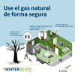Use Natural Gas Safely (Spanish)(Square) Download Graphic
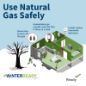Use Natural Gas Safely (Square) Download Graphic
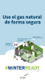Use Natural Gas Safely (Spanish)(Instagram Story) Download Graphic
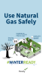Use Natural Gas Safely (Instagram Story) Download Graphic
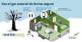Use Natural Gas Safely (Spanish)(Facebook and Twitter) Download Graphic
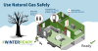Use Natural Gas Safely (Facebook and Twitter) Download Graphic
          - Wood Fire Safety:
- Winter fires can be deadly. When using your fireplace always keep a metal or heat tempered screen around it to stay safe. #WinterReady
- Keep anything that can burn at least 3 feet away from a fireplace, wood stove, or space heater. #WinterReady
Use Your Fireplace Safely gif English
Use Your Fireplace Safely gif Spanish.
Wood Stove Stay Fire Safe This Winter gif English
Wood Stove Stay Fire Safe This Winter gif Spanish.
          - Stay Safe by Staying Inside:
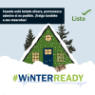Stay Inside When It’s Freezing (Spanish)(Square)Download Graphic
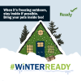 Stay Inside When It’s Freezing (Square) Download Graphic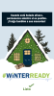 Stay Inside When It’s Freezing (Spanish)(Instagram Story) Download Graphic
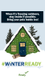 Stay Inside When It’s Freezing (Instagram Story) Download Graphic
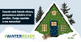 Stay Inside When It’s Freezing (Spanish)(Facebook and Twitter) Download Graphic
        - 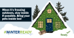 Stay Inside When It’s Freezing (Facebook and Twitter) Download Graphic

        - Sample Winter Travel and Driving Safety Social Media Messages and Graphics:
- Stay off icy roads when #WinterStorm advisories & watches are issued. #WinterReady
- #WinterReady travel tip: follow directions from local officials & build an emergency car kit. More tips www.ready.gov/winter
- Stay off roads during & after a #storm. If you must drive "Don't Crowd the Plow!" #WinterReady
- Prepare your car for winter: keep your gas tank near full to help avoid ice in the tank and fuel lines. #WinterReady
- Ice and snow, take it slow—slower speed, slower acceleration, slower steering, and slower braking. #WinterReady
- It’s best to stay off the roads after a snowstorm but if you must drive don’t crowd the plow, it could affect visibility. Don’t pass snowplows & drive slowly.
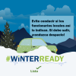 Stay off the Road (Spanish)(Square) Download Graphic
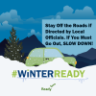 Stay off the Road (Square) Download Graphic
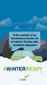 Stay off the Road (Spanish)(Instagram Story) Download Graphic
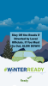Stay off the Road (Instagram Story) Download Graphic
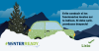Stay off the Road (Facebook and Twitter) Download Graphic
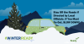Stay off the Road (Facebook and Twitter) Download Graphic

          - Car Safety:
- Snow & ice hazards may create a high risk of car accidents. If your area is expecting winter weather, prepare for safe travel. Pack your vehicle with emergency supplies, including jumper cables, sand, flashlights, phone charger, warm clothes, blankets, & an ice scraper.
- Hitting the road this winter? An emergency kit for your car might come in handy when you least expect it! #WinterReady
- Travel during the winter has unique risks, especially if you travel by car. Being prepared can help you “expect the unexpected” so your trip isn’t ruined by common problems travelers face in the winter.
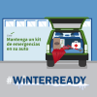 Build an Emergency Car Kit (Spanish)(Square) Download Graphic
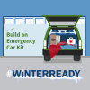 Build an Emergency Car Kit (Square) Download Graphic

Build an Emergency Car Kit (Spanish)(Instagram Story) Download Graphic
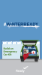 Build An Emergency Car Kit (IG Story) Download Graphic
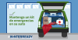 Build an Emergency Car Kit (Spanish)(Facebook and Twitter) Download Graphic
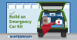 Build an Emergency Car Kit (Facebook and Twitter) Download Graphic

Printable Flyers
These flyers can be printed as handouts, posters or used on your social media or web pages. #WinterReady versions of the graphics will be available on #WinterReady Safety Flyers and Handouts | Ready.gov soon.
Additionally, other fire preparedness materials can be found on the U.S. Fire Administration Fire Prevention and Community Risk Reduction page. Most graphics and publications can be cobranded with your city emergency management or fire department logo.
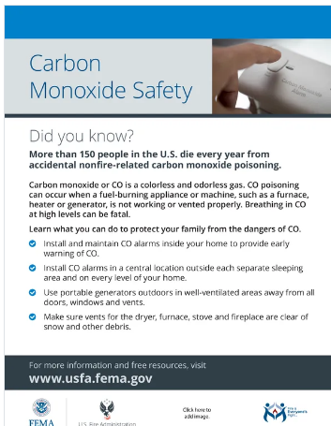 Carbon Monoxide Safety flyer English
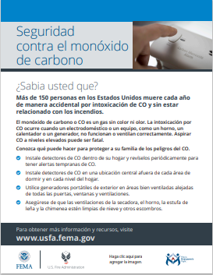 Carbon Monoxide Safety flyer Spanish
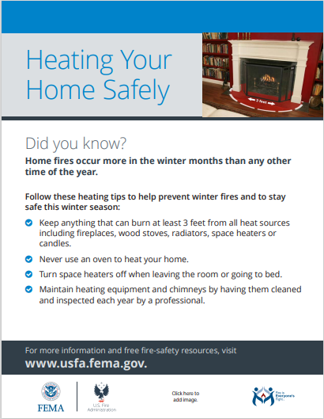 Home Heating Safety flyer English
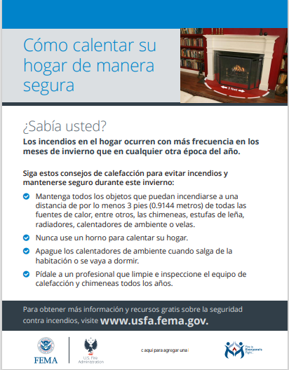 Home Heating Safety flyer Spanish
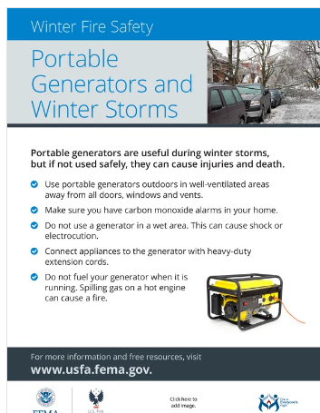 Portable Generators and Winter Storm flyer English
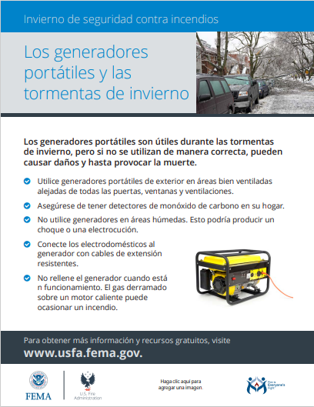 Portable Generators and Winter Storm flyer Spanish
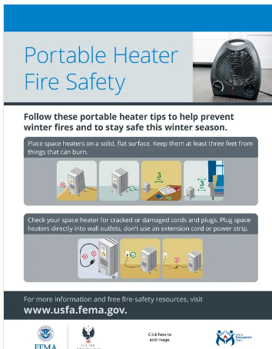 Portable Heater Safety flyer English

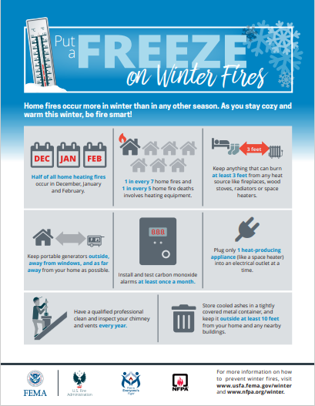 Put a Freeze on Winter Fires flyer English
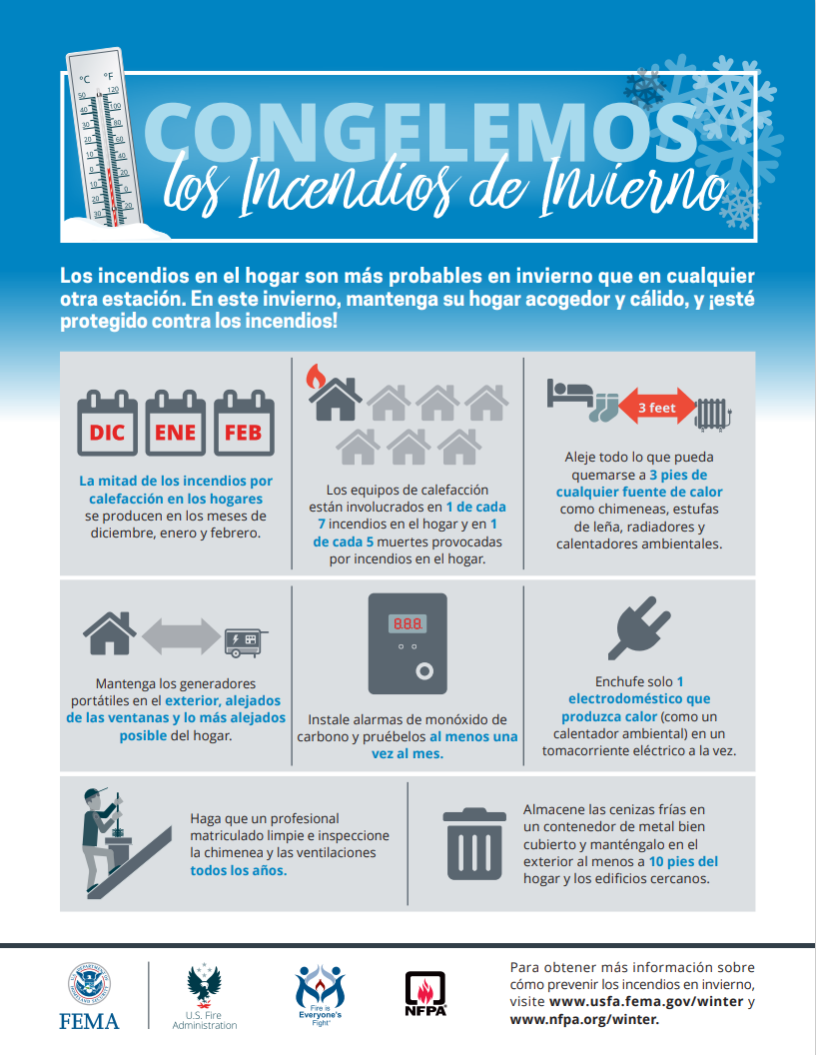 Put a Freeze on Winter Fires flyer Spanish
    - #WinterReady Social Media Toolkits
The #WinterReady toolkit, available in English and Spanish, contains winter weather safety and preparedness messages you can share on your social media channels. You can either copy these messages directly or customize them to reach your audience.

General Preparedness Videos/PSAs
FEMA ASL Accessible: Personal Preparedness: I use a Wheelchair
FEMA ASL Accessible: Be Prepared When Disaster Strikes: What to Know if You Live with a Disability
FEMA ASL Accessible: Be Prepared When Disaster Strikes: What to Know if You Live with a Disability (Spanish captions)
FEMA ASL Accessible: Personal Disaster Preparedness: I am Blind (short)
FEMA | Learn the Sounds of Safety
FEMA | Fire Safety for Older Adults
FEMA | Facts About Fire 2023 (shorts from this video are available on YouTube)
FEMA | What to do during a blizzard
FEMA | During and After a Winter Storm
FEMA | How to Prepare for a Winter Storm
CDC | Prevent Carbon Monoxide Poisoning
CDC | Safe Use of a Portable Generator Following Severe Weather

FEMA Podcasts, Webinars and Blogs
Before, During & After | FEMA.gov
5 Tips to Stay Warm and Safe This Winter | FEMA.gov
Staying Safe During Severe Winter Weather | FEMA.gov
Fire Safety Preparedness and Prevention | FEMA.gov via connectsolutions
A Partridge and A Prepared Me Webinar | FEMA.gov

